IntelliMeet Pro: AI Meeting Assistant & Workflow Management
Final Year Project Proposal
Session FALL 2025
A 4th Year Student

BSc. (Hons.)BS in SE



Department of SE
Fast School of Computing
Fast National University, Karachi Campus
26 August 2025

Project Registration
Project ID (for office use)
Type of project |  |  | [✔] Traditional [ ] Industrial [ ] Continuing
Nature of project |  |  | [✔] Development [ ] Research & Development [ ] Research
Sustainable Development Goals(SDGs) |  |  | [ ] Good Health and Well-Being [ ] Quality Education  [✔] Industry, Innovation, and Infrastructure [ ] Gender Equality  [✔] Decent Work and Economic Growth [ ] Climate Action
Area of specialization |  |  | [✔] Artificial Intelligence (AI) [ ] Data Science and Analytics  [ ] Internet of Things (IoT) [ ] Blockchain  [ ] Mobile App Development [✔] Web Development [ ] Cybersecurity  [ ] Game Development [✔] Natural Language Processing (NLP)  [ ] Other
Project Group Members
Sr.# | Reg. # | Student Name |  | CGPA | Email ID | Phone # | Signature
(i) | 22k-4818 | Mustafa Masood |  | 2.91 | k224818@nu.edu.pk | 03124959170
(ii) | 22k-5195 | Laiba Fatima |  | 3.43 | k225195@nu.edu.pk | 03357213714
(iii)
Declaration: FYP group members have cleared all prerequisite courses For FYP-I as per their degree requirements.

Project Abstract
Traditional minutes of the meeting are written manually, which often suffer from note-taking errors, missed action items, and limited searchability of previous meetings. IntelliMeet Pro provides a solution to these challenges by making use of artificial intelligence to automate meeting transcriptions, generate comprehensive summaries, highlight key takeaway points and actionable items. This ensures that no important discussion is forgotten and participants can remain focused on the discussion rather than the labour that is manual note-taking.
IntelliMeet Pro integrates advanced natural language processing with speaker diarization capabilities to create persistent voice identification across multiple sessions. Beyond transcription and summaries, IntelliMeet Pro transforms meeting discussions into actionable items through integration with popular project management tools. Tasks and decisions made during meetings can be seamlessly integrated into Jira, Trello, and Asana, alongside native Slack bot functionality which further simplifies team communication and collaboration, and provides smooth workflow management.
With the use of IntelliMeet Pro, users can revisit past meeting conversations to retrieve insights instantly through semantic search across all transcripts and summaries. The system also provides a conversational assistant, allowing natural interactions with past meetings to clarify decisions or track progress. To further improve productivity, real-time calendar synchronization makes sure that upcoming meetings are connected automatically, and at the same time, notifications will prepare the participants in advance.
IntelliMeet Pro not only improves efficiency but also ensures continuity across meetings. It bridges the gap between communication and execution by transforming meeting discussions into structured actionable items. By reducing man-made errors, enhancing collaboration between team members, and providing easy access to past conversations, it redefines the meeting experience and enables teams to focus on what matters most i.e. turning words into action and sustaining productivity.

1 Introduction
Team collaboration and meetings are an essential part of any organisation, but they are challenging to organise and manage [10]. With the rise in geographically dispersed teams, the COVID-19 pandemic, and shift towards remote work, organizations are increasingly adopting online web conferencing tools to hold meetings [1, 2]. Organizations that use platforms like Zoom, Google Meet, and Microsoft Teams generate a considerable amount of conversational data that contains critical business intelligence, project updates, and strategic decisions. Unfortunately, most of this information is not used because of the absence of tools that are able to record, structure, and transform discussions into actionable items. Traditional practices for capturing meeting content, such as paper and electronic note-taking, are often informal and burdensome on meeting participants [3].
The objective of IntelliMeet Pro is to design and develop an intelligent meeting assistant that makes use of natural language processing (NLP) to transcribe, analyze, and summarize meeting conversations. IntelliMeet Pro will not only provide searchable transcripts but also extract decisions, assign tasks, and integrate them with popular project management tools to ensure continuity across meetings.
To achieve this, the project will be divided into sub-tasks such as speech-to-text transcription, speaker diarization for persistent identification, semantic summarization of discussions, and integration with tools like Jira, Trello, and Slack. Techniques such as transformer-based NLP models, semantic search algorithms, and real-time API integrations will be adopted.
The success of the project will be measured using criteria such as transcription accuracy, relevance of extracted decisions, efficiency of task integration, and user satisfaction in improving meeting productivity. By meeting these goals, the system will bridge the gap between communication and execution, ultimately enabling teams to collaborate more effectively in digital workspaces.

2 Success Criterion
The project success will be evaluated based on the following measurable technical deliverables:
• Deployment of AI bot that can automatically join and record meetings on Zoom, Google Meet, and Microsoft Teams with 95% reliability.
• Transcription accuracy rates exceed 90% for English language meetings with proper speaker identification.
• Generation of clear meeting summaries within 5 minutes of meeting conclusion with action items correctly attributed to participants.
• Implementation of semantic search functionality capable of retrieving relevant information from meeting transcripts with response times under 1 minute.
• Successful integration with at least 3 project management platforms (Jira, Asana, Trello) with automatic action item synchronization.
• Deployment of functional Slack bot supporting conversational queries about meeting content with 90% accuracy.
• Implementation of secure payment processing system supporting multiple subscription tiers with webhook validation.
• Achievement of system response times under 30 seconds for all user interface interactions.
• Successful implementation of transcript translation supporting English and Urdu.
• Deployment of workspace functionality supporting team collaboration with role-based access control.

3 Related work
Existing research on AI-assisted meeting understanding has advanced in transcription, summarization, and workflow integration, but key gaps remain. LLM-powered recap systems from Microsoft and HCI studies demonstrate that structured highlights and hierarchical minutes improve recall and coordination [13]. Benchmark datasets such as MeetingBank [16] and MUG [17] enable supervised training for summarization and action detection, though they lack evidence-linked outputs. Real-time pipelines now achieve sub-200 ms multilingual transcription [18] and online summarization policies balance latency and quality [19], yet most omit persistent diarization and auto-join across platforms.
Advances in diarization through multimodal challenges [20] and multi-agent systems for task extraction [21] show promise but remain limited in stability, structured action extraction, and bidirectional project management integration. In summary, while scalability and transcription accuracy are improving, current systems fall short on grounded, actionable, and enterprise-ready solutions.
Some systems have aimed to bridge this gap; for example, TalkTraces maps discussion content to the meeting agenda in real-time[4], and MeetScript provides real-time transcripts that participants can collaboratively annotate to make sense of meeting content [5]. However, previous studies have shown that when providing real-time assistance to meeting participants, it can place a higher burden on people because they need to consume additional information simultaneously, for example, transcripts and visualizations [4, 5].
Otter.ai represents the current market leader, offering real-time transcription and basic summarization capabilities. The platform excels in speaker identification and live transcript sharing but lacks advanced semantic search capabilities and comprehensive project management integrations.
Fireflies.ai provides comprehensive meeting analytics with strong integration capabilities across various business applications. The platform offers support for multiple languages. However, it struggles with complex multi-speaker environments and lacks sophisticated natural language processing for action item extraction.
IntelliMeet Pro differentiates itself through several key innovations: persistent voice identification across multiple meetings to create speaker profiles, advanced RAG (Retrieval Augmented Generation) pipeline using Pinecone vector database for superior semantic search, native Slack bot integration with conversational AI for natural queries, comprehensive workspace management with shared meeting histories, one-click action item synchronization across multiple project management platforms, and security with webhook validation and encrypted storage.

4 Project Rationale
Effective meeting management remains a critical challenge for modern organizations, where time-consuming discussions often lead to information overload, missed action items, and fragmented follow-ups. Existing meeting platforms provide basic transcription and recording but lack mechanisms for structured summarization, and seamless integration with enterprise workflows.
With the rapid advances in AI, particularly large language models, semantic search, and speaker diarization there is a unique opportunity to transform raw meeting conversations into actionable, persistent knowledge assets. IntelliMeet Pro is motivated by the need to bridge this gap by developing an AI assistant capable of autonomous meeting participation, accurate speaker profiling, and direct synchronization with project management tools such as Jira, Trello, and Asana.
From an academic perspective, the project contributes to applied research in natural language processing, retrieval-augmented generation, and multi-modal diarization, while also addressing engineering challenges in cloud deployment, real-time data processing, and secure role-based collaboration.

4.1 Aims and Objectives
The primary aim of IntelliMeet Pro is to revolutionize organizational meeting management through intelligent automation and comprehensive workflow integration. The specific objectives include:
• Develop an autonomous AI bot system capable of joining scheduled meetings across Zoom, Google Meet, and Microsoft Teams without manual intervention
• Implement advanced speaker diarization with persistent voice identification to create comprehensive participant profiles across multiple meetings
• Create intelligent meeting summarization using large language models with automatic action item extraction and participant attribution
• Build a sophisticated semantic search system using vector databases to enable natural language queries across entire meeting databases
• Establish seamless integrations with project management platforms including automatic action item synchronization and status tracking
• Develop a conversational Slack bot interface supporting complex queries about meeting content and organizational knowledge
• Implement secure payment processing with three-tier subscription model supporting individual and enterprise customers
• Create comprehensive workspace management functionality enabling team collaboration with role-based access control
• Develop transcript translation capabilities supporting over English and Urdu through Google Cloud Translation API
• Build responsive web application with modern user interface supporting real-time collaboration and meeting management

4.2 Scope of the Project

4.2.1 In-Scope Deliverables:
• Automated AI bot deployment system for Zoom, Google Meet, and Microsoft Teams
• Real-time meeting transcription with advanced speaker diarization and persistent voice identification
• AI-powered meeting summarization and action item extraction using OpenAI GPT models
• Semantic search functionality using Pinecone vector database with RAG pipeline implementation
• Integration with Jira, Asana, and Trello for automatic action item synchronization
• Native Slack bot supporting conversational queries using Bolt framework
• Three-tier subscription system with Stripe payment processing and webhook validation
• Secure authentication and session management using ASP.NET Core Identity
• Modern responsive web interface using React, TailwindCSS 4, and Shadcn UI components
• Comprehensive meeting dashboard with audio playback and historical navigation
• Transcript translation using Google Cloud Translation API
• Workspace management with team collaboration and member invitation functionality
• Real-time notifications system using Sonner with email notifications via Resend
• Cloud storage integration using Azure Blob Storage for audio files and user profiles

4.2.2 Out-of-Scope Limitations:
• Real-time video processing and computer vision features
• Mobile application development for iOS and Android platforms
• Advanced analytics and business intelligence reporting beyond basic meeting metrics
• Integration with customer relationship management (CRM) systems
• Voice synthesis and text-to-speech capabilities
• Advanced security features such as end-to-end encryption for stored content
• Integration with human resources management systems
• Advanced workflow automation beyond basic action item tracking
• Multi-tenant architecture supporting white-label deployments
• Advanced AI training and model fine-tuning capabilities

5 Proposed Methodology and Architecture

5.1 Proposed Methodology
The development of IntelliMeet Pro will follow the Waterfall Development Model, ensuring a structured, sequential progression through distinct phases. Each phase must be completed and reviewed before moving to the next, minimizing ambiguity and ensuring clear documentation at every stage. This methodology is best suited for projects where requirements are well understood upfront and stability is prioritized over frequent iteration.
The Waterfall model provides a linear roadmap that covers requirements gathering, design, implementation, testing, deployment, and maintenance, with each stage producing formal deliverables that guide the next.

5.1.1 Waterfall Process Phases
The project will proceed through the following phases:
Phase 1: Requirements Analysis (Sept – Oct 2025)
- Gather and document requirements through stakeholder meetings.
- Develop the Software Requirements Specification (SRS).
- Conduct literature review to validate feasibility.
Phase 2: System Design (Oct 2025)
- Design system architecture, data flow, and interaction layers.
- Create database schema and ERD diagrams.
- Prepare wireframes and UI prototypes.
- Document the Software Design Specification (SDS).
Phase 3: Implementation (Nov 2025 – Mar 2026)
- Develop modules in a sequential manner:
  - Authentication & Scheduling
  - AI Transcription & Diarization
  - Meeting Summarization & Action Items
  - Semantic Search & Workflow Integrations
  - Slack Bot, UI/UX, Bilingual Support, Payment & Notifications
- Code development aligned with the finalized SDS.
Phase 4: Integration & Testing (Jan – Apr 2026)
- Conduct module-level testing, followed by system-wide integration testing.
- Debug and refine each component.
- Perform Quality Assurance (QA), scalability testing, and performance evaluation.
Phase 5: Deployment & Documentation (Apr – May 2026)
- Deploy IntelliMeet Pro to cloud infrastructure.
- Deliver user manuals, technical reports, and training materials.
- Conduct stakeholder training and demonstration sessions.
Phase 6: Final Evaluation & Presentation (May 2026)
- Prepare an open house demo.
- Conduct final project defense, viva, and evaluation.
- Submit retirement planning report and final deliverables.

5.1.2 Milestones and Deliverables
Each phase will conclude with a review milestone ensuring completeness before moving forward:
- Requirements → Approved SRS
- Design → Approved SDS & ERD
- Implementation → Working modules
- Testing → Validated system functionality
- Deployment → Live system & documentation
- Evaluation → Final defense & submission

5.2 Proposed Architecture
The system will adopt a Layered Architecture Pattern, ensuring modularity, scalability, and maintainability. Each layer is responsible for a distinct set of operations and interacts only with adjacent layers, which enhances separation of concerns and supports flexible integration.

5.2.1 Layered Architecture Overview
The architecture is divided into four primary layers:
- Presentation Layer (UI/UX)
  - Responsibilities: Provides the user interface for web applications and Slack bot interactions. Ensures responsive design, intuitive navigation, and real-time updates. Built using React, TailwindCSS, and Shadcn UI.
  - Interaction: Receives user inputs, forwards them to the application layer, and displays processed results such as transcripts, summaries, and action items.
- Application Layer (Business Logic)
  - Responsibilities: Implements business rules, workflows, and orchestration of meeting processing tasks. Manages transcription pipelines, summarization workflows, task assignment, and integration with project management systems.
  - Interaction: Coordinates with both the data layer for persistence and the integration layer for external API communication.
- Data Layer (Persistence and Storage)
  - Responsibilities: Manages structured and unstructured data, including transcripts, speaker profiles, meeting summaries, and action items. Ensures secure storage, indexing, and retrieval of meeting data using SQL Server, Azure Blob Storage, and Pinecone vector database.
  - Interaction: Provides abstracted access to persistent data for the application layer while ensuring data integrity and scalability.
- Integration Layer (External Services and APIs)
  - Responsibilities: Handles interactions with third-party services and APIs such as Zoom, Google Meet, Microsoft Teams, Slack, Jira, Trello, Asana, Stripe, and Google Cloud Translation. Ensures seamless interoperability and extensibility.
  - Interaction: Abstracts external service details from the application layer, ensuring modular integration and adaptability.

5.2.2 System Flow
A typical system interaction proceeds as follows:
- The Presentation Layer captures a user action (e.g., scheduling a meeting or querying past transcripts).
- The request is processed by the Application Layer, where business logic determines workflows such as joining a meeting, processing audio, or generating a summary.
- The Application Layer retrieves or stores necessary data via the Data Layer.
- If external services are required (e.g., Slack query, Jira integration, or Stripe subscription validation), the Application Layer communicates with the Integration Layer, which handles the API calls.
- Results are propagated back up to the Presentation Layer, ensuring seamless user interaction.

5.2.3 Architecture Diagram
The overall system flow is illustrated in the IntelliMeet Pro architecture diagram, see Fig.1.
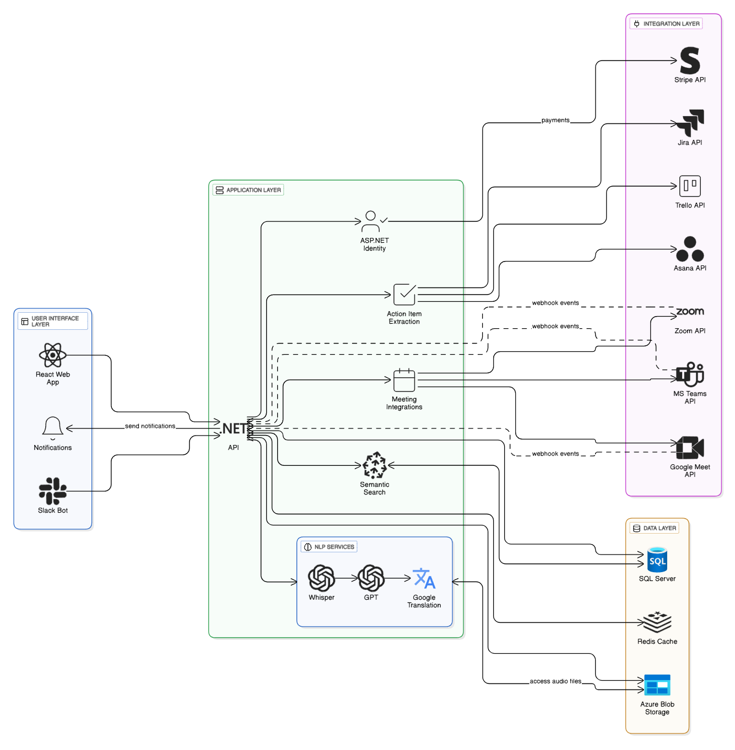
Fig.1. Architecture Diagram

6 Individual Tasks
The detailed distribution of individual tasks among project members is provided in Table 1.
Table 1. Individual Tasks
Team Member | Activity | Tentative Date
Mustafa Masood | Stakeholder meetings & architectural planning (System Architecture & Layered Design) | Sept 25, 2025 – Oct 5, 2025
Laiba Fatima | Literature review, UI concept sketching & documentation assistance | Oct 6, 2025 – Oct 20, 2025
Laiba Fatima | Database schema design and ERD creation | Oct 21, 2025 – Nov 5, 2025
Mustafa Masood | SDS creation and backend architecture planning (API scaffolding) | Nov 6, 2025 – Nov 15, 2025
Laiba Fatima | UI Wireframes and prototype development | Nov 16, 2025 – Dec 5, 2025
Mustafa Masood | Authentication & scheduling module (backend) | Dec 16, 2025 – Jan 5, 2026
Laiba Fatima | Frontend for authentication module (UI implementation) | Jan 6, 2026 – Jan 15, 2026
Mustafa Masood | AI transcription & diarization module (backend) | Jan 16, 2026 – Jan 31, 2026
Laiba Fatima | Transcription frontend: real-time updates & UI integration | Feb 1, 2026 – Feb 10, 2026
Mustafa Masood | Meeting summarization & insights extraction | Feb 11, 2026 – Feb 25, 2026
Laiba Fatima | Action item extraction UI & dashboard design | Feb 26, 2026 – Mar 5, 2026
Mustafa Masood | Full system integration (backend + AI modules) | Mar 6, 2026 – Mar 15, 2026
Laiba Fatima | UI integration & testing of complete system | Mar 16, 2026 – Mar 25, 2026
Laiba Fatima | QA testing, usability testing, reporting | Mar 26, 2026 – Apr 5, 2026
Mustafa Masood | Final debugging & performance optimization | Apr 6, 2026 – Apr 15, 2026
Laiba Fatima | Final presentation slides & open house material prep | Apr 16, 2026 – Apr 25, 2026
Mustafa Masood | Deployment to cloud, technical documentation, support | Apr 26, 2026 – May 5, 2026

7 Gantt Chart
The overall project timeline, including phases and tasks is illustrated in Fig.2. through the Gantt chart
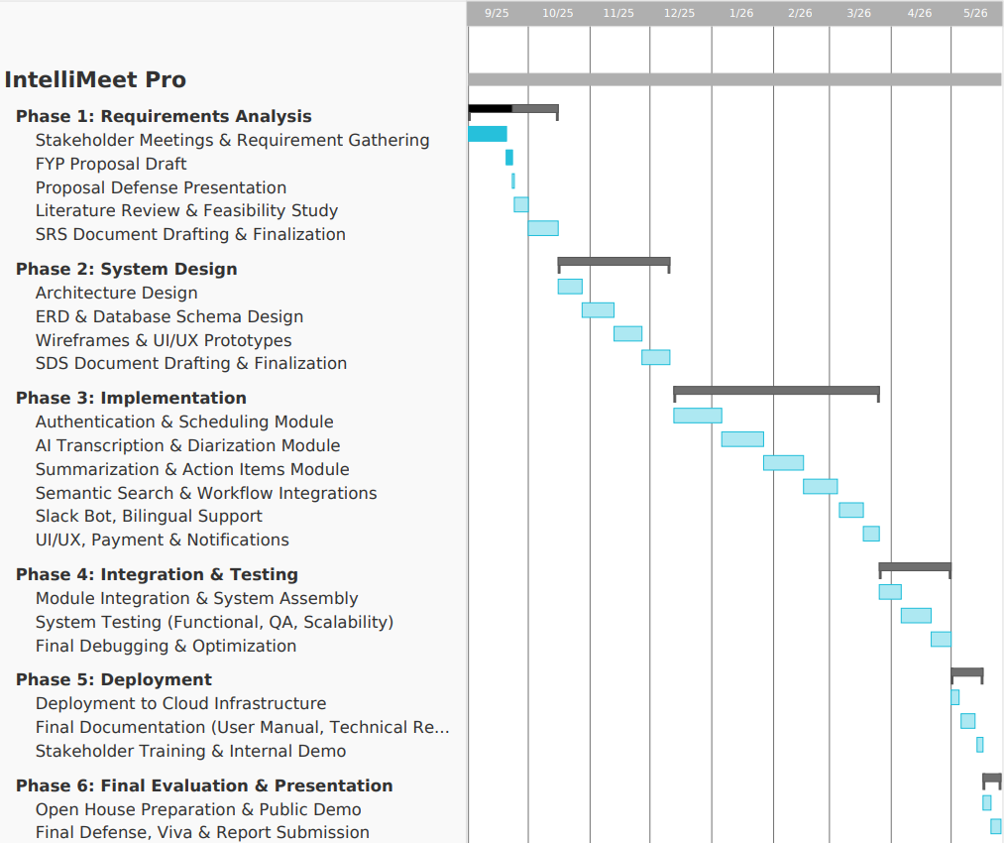
Fig.2. Gantt Chart

8 Tools and Technologies
Programming Languages:
• C# for backend development with ASP.NET Core framework
• TypeScript/JavaScript for frontend development with React
• SQL for database queries and stored procedures
Backend Frameworks and Technologies:
• ASP.NET Core 8.0 for web API development and microservices architecture
• Entity Framework Core for object-relational mapping and database operations
• Azure Functions for serverless computing and automated webhook processing
• ASP.NET Core Identity for authentication and authorization management
Frontend Technologies:
• React 18 for component-based user interface development
• TypeScript for type-safe JavaScript development
• TailwindCSS 4 for utility-first responsive styling framework
• Shadcn UI for accessible and customizable component library
• Next Themes for dark mode and theme management
AI and Machine Learning:
• OpenAI (Whisper, GPT-4) for transcription and natural language processing
• Pinecone Vector Database for semantic search and retrieval augmented generation
• Google Cloud Translation API for English and Urdu transcript translation support
Communication Platform Integration:
• Zoom SDK for automated meeting joining and recording capabilities
• Google Meet API for web conferencing platform integration
• Microsoft Teams API for enterprise communication platform support
• Slack Bolt Framework for native bot development and conversational AI
Project Management and Productivity:
• Jira REST API for project management integration
• Asana API for project management integration
• Trello API for project management integration
Payment Processing and Security:
• Stripe API for secure payment processing and subscription management
• Svix for webhook signature validation and security
• Azure Key Vault for secure credential and secret management
Cloud Infrastructure and Storage:
• Microsoft Azure for cloud hosting and scalable infrastructure
• Azure Blob Storage for audio file storage and media management
• SQL Server for structured data storage and relational database management
• Redis for caching and session management
Development and Deployment Tools:
• Visual Studio 2022 for backend C# development and debugging
• Visual Studio Code for frontend TypeScript/React development
• Git and GitHub for version control and collaborative development
• Azure DevOps for continuous integration and deployment pipelines

9 References
[1] Jaime Teevan, Nancy Baym, Jenna Butler, Brent Hecht, Sonia Jaffe, Kate Nowak, Abigail Sellen, Longqi Yang, Marcus Ash, Kagonya Awori, Mia Bruch, Piali Choudhury, Adam Coleman, Scott Counts, Shiraz Cupala, Mary Czerwinski, Ed Doran, Elizabeth Fetterolf, Mar Gonzalez Franco, Kunal Gupta, Aaron L Halfaker, Constance Hadley, Brian Houck, Kori Inkpen, Shamsi Iqbal, Eric Knudsen, Stacey Levine, Siân Lindley, Jennifer Neville, Jacki O’Neill, Rick Pollak, Victor Poznanski, Sean Rintel, Neha Parikh Shah, Siddharth Suri, Adam D. Troy, and Mengting Wan. 2022. Microsoft New Future of Work Report 2022. Technical Report MSR-TR-2022-3. Microsoft. https://www.microsoft.com/enus/research/publication/microsoft-new-future-of-work-report-2022/
[2] Nicole Yankelovich, William Walker, Patricia Roberts, Mike Wessler, Jonathan Kaplan, and Joe Provino. 2004. Meeting Central: Making Distributed Meetings More Effective. In Proceedings of the 2004 ACM Conference on Computer Supported Cooperative Work (Chicago, Illinois, USA) (CSCW ’04). Association for Computing Machinery, New York, NY, USA, 419–428. https://doi.org/10.1145/1031607.1031678
[3] Vaiva Kalnikaite, Patrick Ehlen, and Steve Whittaker. 2012. Markup as You Talk: Establishing Effective Memory Cues While Still Contributing to a Meeting. In Proceedings of the ACM 2012 Conference on Computer Supported Cooperative Work (Seattle, Washington, USA) (CSCW ’12). Association for Computing Machinery, New York, NY, USA, 349–358. https://doi.org/10.1145/2145204.2145260
[4] Senthil Chandrasegaran, Chris Bryan, Hidekazu Shidara, Tung-Yen Chuang, and Kwan-Liu Ma. 2019. TalkTraces: real-time capture and visualization of verbal content in meetings. In Proceedings of the 2019 CHI Conference on Human Factors in Computing Systems. 1–14.
[5] Xinyue Chen, Shuo Li, Shipeng Liu, Robin Fowler, and Xu Wang. 2023. MeetScript: Designing Transcript-based Interactions to Support Active Participation in Group Video Meetings. Proceedings of the ACM on Human-Computer Interaction 7, CSCW2 (2023), 1–32. https://doi.org/10.1145/3610196
[6] Otter.ai. 2023. https://help.otter.ai/hc/en-us/articles/5093383818263-Automated-Live-Summary-Overview
[7] Sumit Asthana, Sagih Hilleli, Pengcheng He, and Aaron Halfaker. 2023. Summaries, Highlights, and Action items: Design, implementation and evaluation of an LLM-powered meeting recap system. arXiv preprint arXiv:2307.15793 (2023).
[8] Gregorio Convertino, Helena M Mentis, Mary Beth Rosson, John M Carroll, Aleksandra Slavkovic, and Craig H Ganoe. 2008. Articulating common ground in cooperative work: content and process. In Proceedings of the SIGCHI conference on human factors in computing systems. 1637–1646.
[9] Ruochen Xu, Chenguang Zhu, and Michael Zeng. 2022. Narrate Dialogues for Better Summarization. In Findings of the Association for Computational Linguistics: EMNLP 2022. Association for Computational Linguistics, Abu Dhabi, United Arab Emirates, 3565–3575. https://doi.org/10.18653/v1/2022.findings-emnlp.261
[10]Beatriz Cabrero-Daniel, Tomas Herda, Victoria Pichler, and Martin Eder 2024. “Exploring Human-AI Collaboration in Agile: Customised LLM Meeting Assistants”. https://doi.org/10.48550/arXiv.2404.14871
[11] Sumit Asthana, Sagi Hilleli, Pengcheng He, and Aaron Halfaker 2025. “Summaries, Highlights, and Action Items: Design, Implementation and Evaluation of an LLM-powered Meeting Recap System”. https://dl.acm.org/doi/10.1145/3711074
[12] Xinyue Chen, Nathan Yap, Xinyi Lu, Aylin Gunal, and Xu Wang 2025. “MeetMap: Real-Time Collaborative Dialogue Mapping with LLMs in Online Meetings”. https://dl.acm.org/doi/10.1145/3711030
[13] S. Asthana, S. Hilleli, P. He, and A. Halfaker, “Summaries, highlights, and action items: Design, implementation and evaluation of an LLM-powered meeting recap system,” Proc. ACM Hum.-Comput. Interact., vol. 7, no. CSCW1, pp. 1–29, Apr. 2023, https://dl.acm.org/doi/10.1145/3711074
[14] M. T. R. Laskar, H. Ji, and J. Liu, “Query-OPT: Optimizing inference of large language models via multi-query instructions in meeting summarization,” in Proc. 2024 Conf. Empirical Methods in Natural Language Processing (EMNLP), Miami, FL, USA, Nov. 2024, pp. 1–12.
[15] F. Kirstein, D. Schlangen, and C. Malon, “Tell me what I need to know: Exploring LLM-based (personalized) abstractive multi-source meeting summarization,” arXiv preprint, https://arxiv.org/abs/2410.14545
[16] Y. Hu, W. Shi, Z. Feng, and D. Ji, “MeetingBank: A benchmark dataset for meeting summarization,” arXiv preprint, https://arxiv.org/abs/2305.17529
[17] Q. Zhang, J. Wang, Y. Liu, and F. Wei, “MUG: A general meeting understanding and generation benchmark,” in Proc. IEEE Int. Conf. Acoustics, Speech and Signal Processing (ICASSP), Rhodes, Greece, Jun. 2023, pp. 1–5, https://arxiv.org/abs/2303.13939
[18] G. Wang, J. Li, and Y. Chen, “Research on real-time multilingual transcription and minutes generation for video conferences based on large language models,” Int. J. Innov. Res. Eng. Manag., vol. 9, no. 3, pp. 45–52, 2024.
[19] F. Schneider, T. Baumgartner, and M. Cieliebak, “Policies and evaluation for online meeting summarization,” arXiv preprint, https://arxiv.org/abs/2502.03111
[20] M. Gao, Z. Duan, and T. Yoshioka, “The multimodal information based speech processing (MISP) 2025 challenge: Audio-visual diarization and recognition,” arXiv preprint, https://arxiv.org/abs/2505.13971
[21] Á. Varjú and P. Varga, “Multi-agent LLM system for automatic meeting information processing,” in Proc. IEEE/IFIP Netw. Oper. Manag. Symp. (NOMS), Seoul, South Korea, Apr. 2025, pp. 1–9, https://www.researchgate.net/publication/393741379_Multi-Agent_LLM_System_for_Automatic_Meeting_Information_Processing

